1. 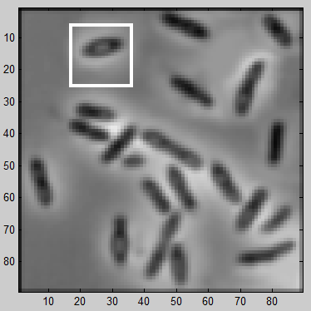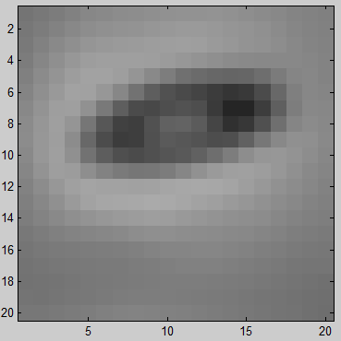[15 Marks]

You have been tasked with writing a program to analyze images of bacteria taken by a microscope. A sample image is shown on the right, along with a small blown up portion from the top left of the original image:

The actual gray-level values in the small 20x20 portion of the image are given below:

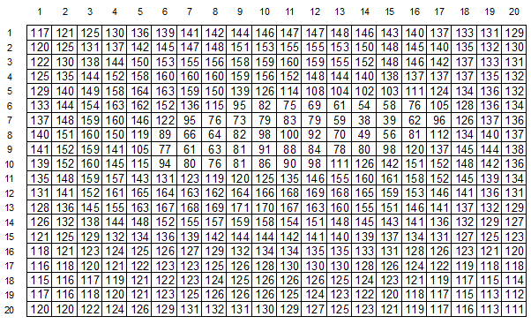

Parallel to vertical axis

Parallel to horizontal axis

*In the questions below, you may assume that the simple finite derivative masks discussed in class (i.e. of type [-1 1]) are used to compute the gradient direction, and the convention of the axes is the same as that preferred in class.*

* 1. [5 Marks] On the grid of numbers shown above, mark a location where the gradient direction is exactly parallel to the horizontal axis, and another location where the gradient direction is exactly parallel to the vertical axis.
  2. [5 Marks] Using the convention of axes used in class, compute gradient magnitude and direction at pixel location (8, 16) and (18, 9). [*If you do not have a calculator, you can just plug the values in the appropriate formula*].

At (8,16), fx = 81 – 62 = 19 fy = 81 – 56 = 25

magnitude = (192 + 252)0.5 = 31.4

direction = atan(25/19) = 52.76o

At (18,9), fx = 125 – 126 = -1 fy = 125 – 124 = +1

magnitude = (-12 + 12)0.5 = 1.41

direction = atan(1/-1) = -45o

* 1. [5 Marks] Your friend argues that the gradient direction value computed at one of the pixels above is more ‘reliable’ than the other. Do you agree or disagree? Explain your position.

At (8,16), the difference between neighboring pixels is large, so the direction is reliably established. However, at (18,9), the difference between neighboring pixels is only 1 and likely a result of noise. The gradient direction will not be reliable here.

1. [10 Marks]Write the Algorithm for HOG Feature/Descriptor Detection. (See the Lecture Slides)